# Project Unit – Evidence

## **David Ellis**

## **Cohort E18**

## P1 – Group Project – GitHub Contributors Page Screenshot

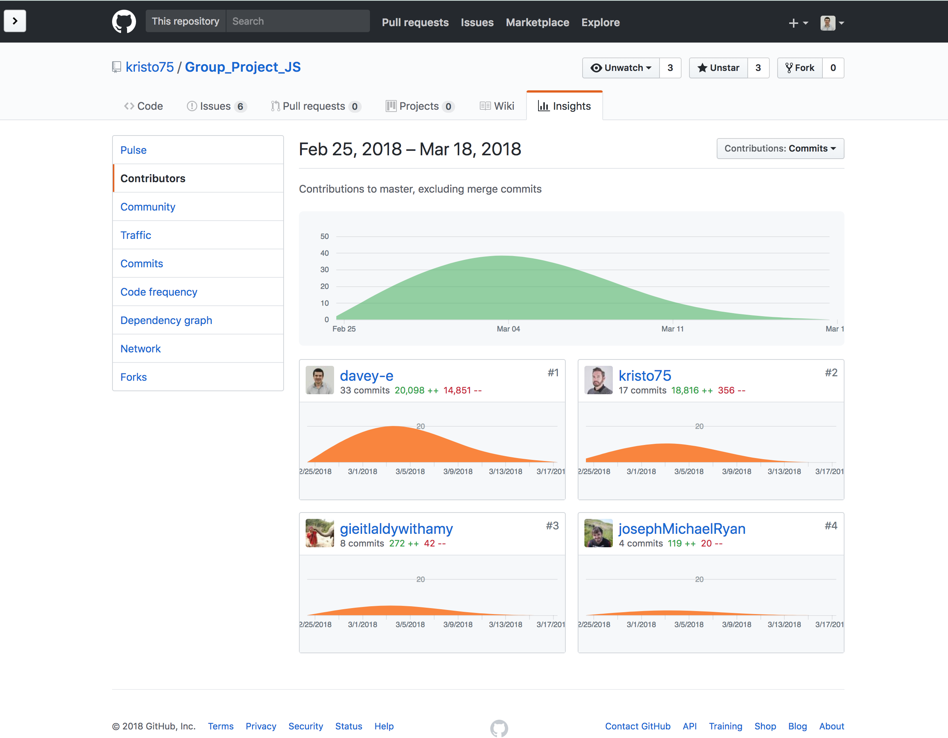

## P2 – Group Project – Project Brief Screenshots

### Project Brief From Classnotes:

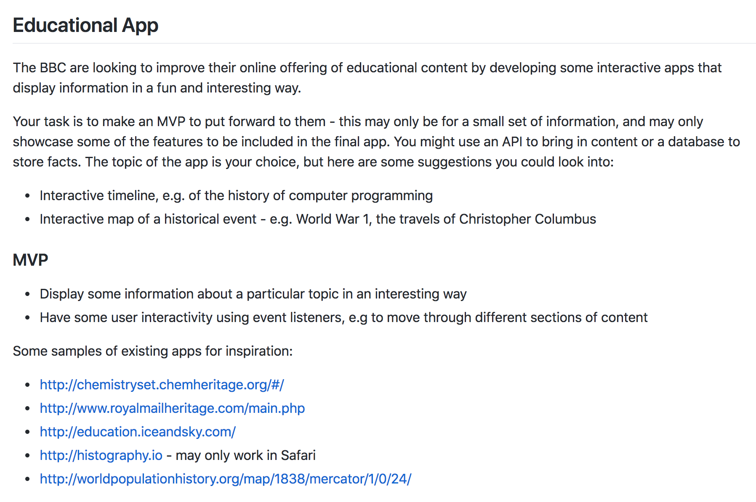

### Project brief that we created for our specific app:

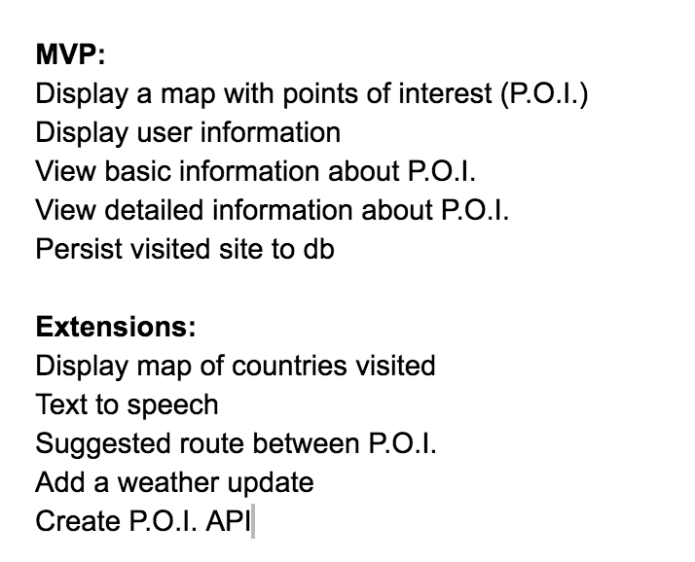

## P3 – Group Project – Planning Screenshots

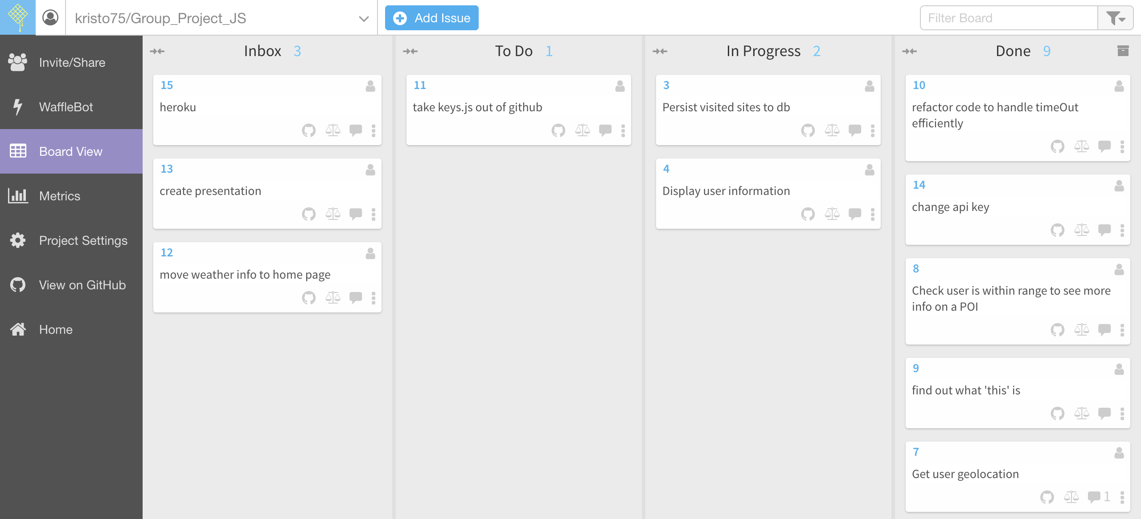

## P4 – Acceptance Criteria and Test Plan

|  |  |  |
| --- | --- | --- |
| Acceptance Criteria | Expected Result/Output | Pass/Fail |
| A user is able to see a list of all transactions in the system for all tags | The main page of the app displays a table with all of the transactions for all tags fetched from the database shown. The table can be scrolled to shown transactions that are at the bottom of the table | Pass |
| A user is able to see the total amount spent for all transactions for all tags | The main page of the app displays the total amount of all transactions in the header bar | Pass |
| A user is able to see a list of the available tags that can be selected to filter the data | The main page of the app shows buttons for each of the tags that are in the system in the navigation bar on the left-hand side. | Pass |
| A user is able to filter the data by selecting one of the available tags | The user can click on each tag button in the navigation bar on the left-hand side to filter the data in the table by tag |  |
| A user is able to add a new transaction to the system | A New Transaction button is displayed on the navigation bar on the left-hand side of the main page of the app. When the user clicks on this button a form is displayed to allow the user to ender the transaction data | Pass |
| A user is able to select the date, amount, tag and vendor when adding a new transaction | The New Transaction form displays input elements for date, amount, tag and vendor and also displays a Submit button | Pass |
| A user is able to add a new tag to the system | A New Tag button is displayed on the navigation bar on the left-hand side of the main page of the app. When the user clicks on this button a form is displayed to allow the user to ender the new tag | Pass |
| A user is able to add a new vendor to the system | A New Vendor button is displayed on the navigation bar on the left-hand side of the main page of the app. When the user clicks on this button a form is displayed to allow the user to ender the new vendor | Pass |

## P5 – User Sitemap *W5

Create a user sitemap

Generate this in draw.io, just a simple flow diagram

## P6 – Wireframe Diagrams





## P7 – System Interaction Diagrams *W14

Produce two system interaction diagrams (sequence and/or collaboration diagrams: 2 sequence diagrams, 2 collaboration diagrams or 1 of each).

## P8 – Object Diagrams (2) *W14

Produce two object diagrams.

## P9 – Algorithm Example Screenshots and Explanations*W14

Select two algorithms you have written (NOT the group project). Take a screenshot of each and write a short statement on why you have chosen to use those algorithms.

## P10 – Pseudocode Example Screenshot

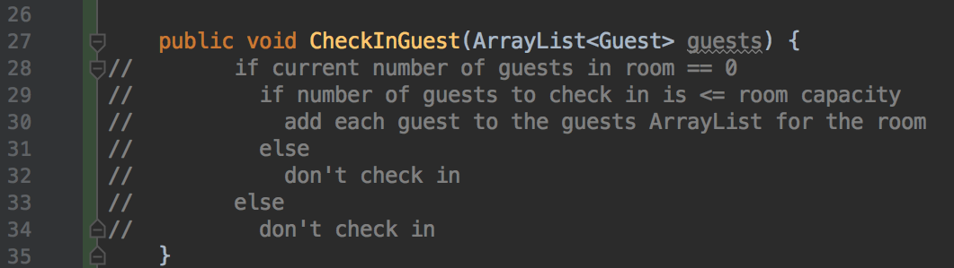

## P11 – Individual Project Screenshot and GitHub Link

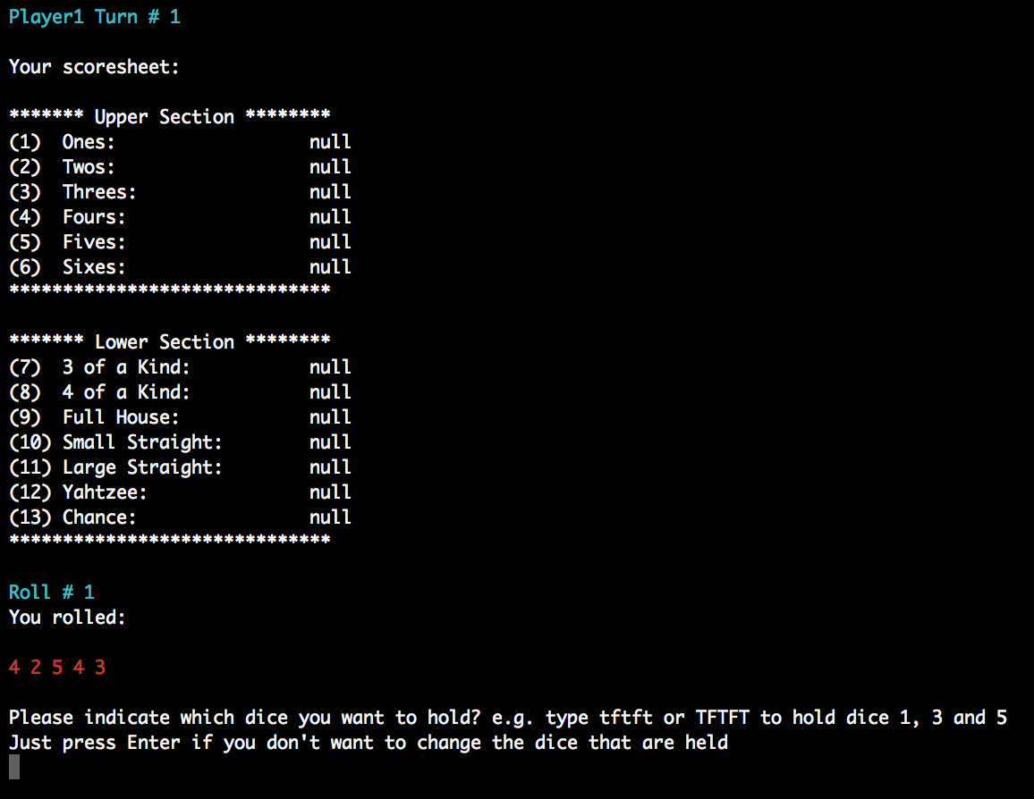

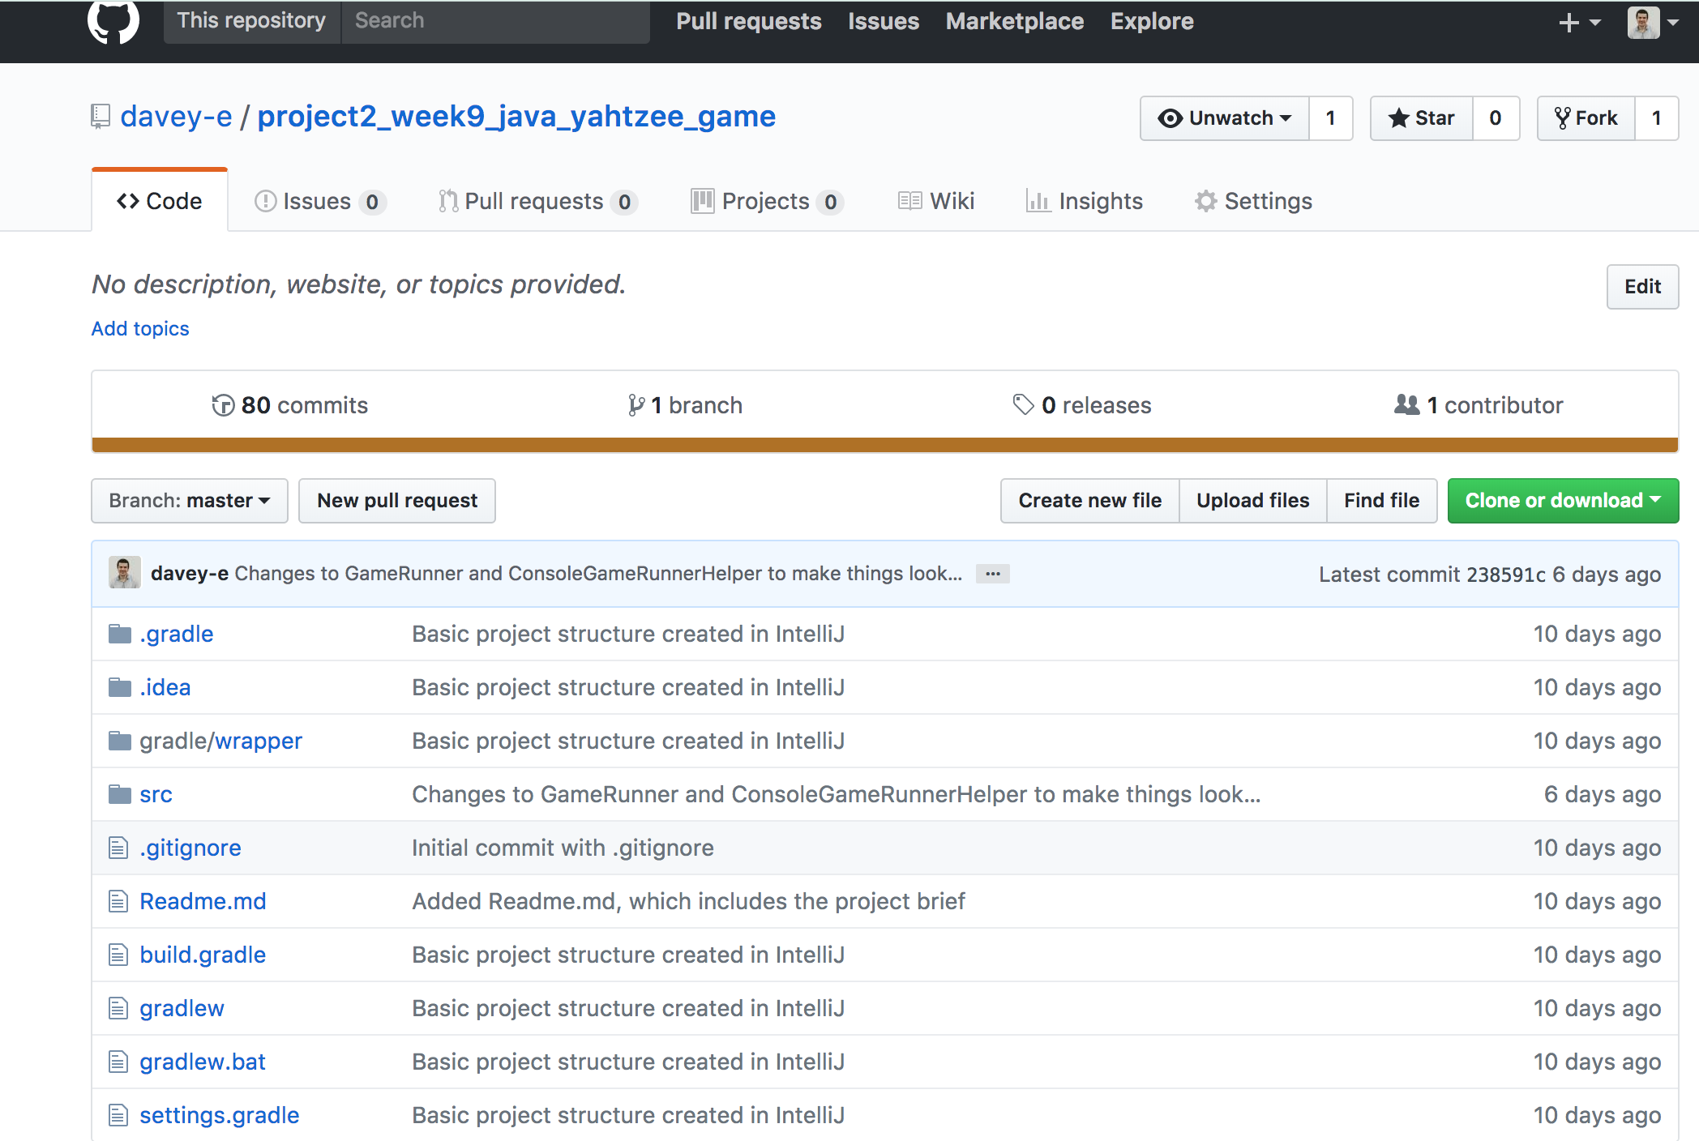

<https://github.com/davey-e/project2_week9_java_yahtzee_game>

## P12 – Project Planning Screenshots/Photos at Different Stages *W9

Take screenshots or photos of your planning and the different stages of development to show changes.

## P13 – User Input Processing Screenshots

User input:

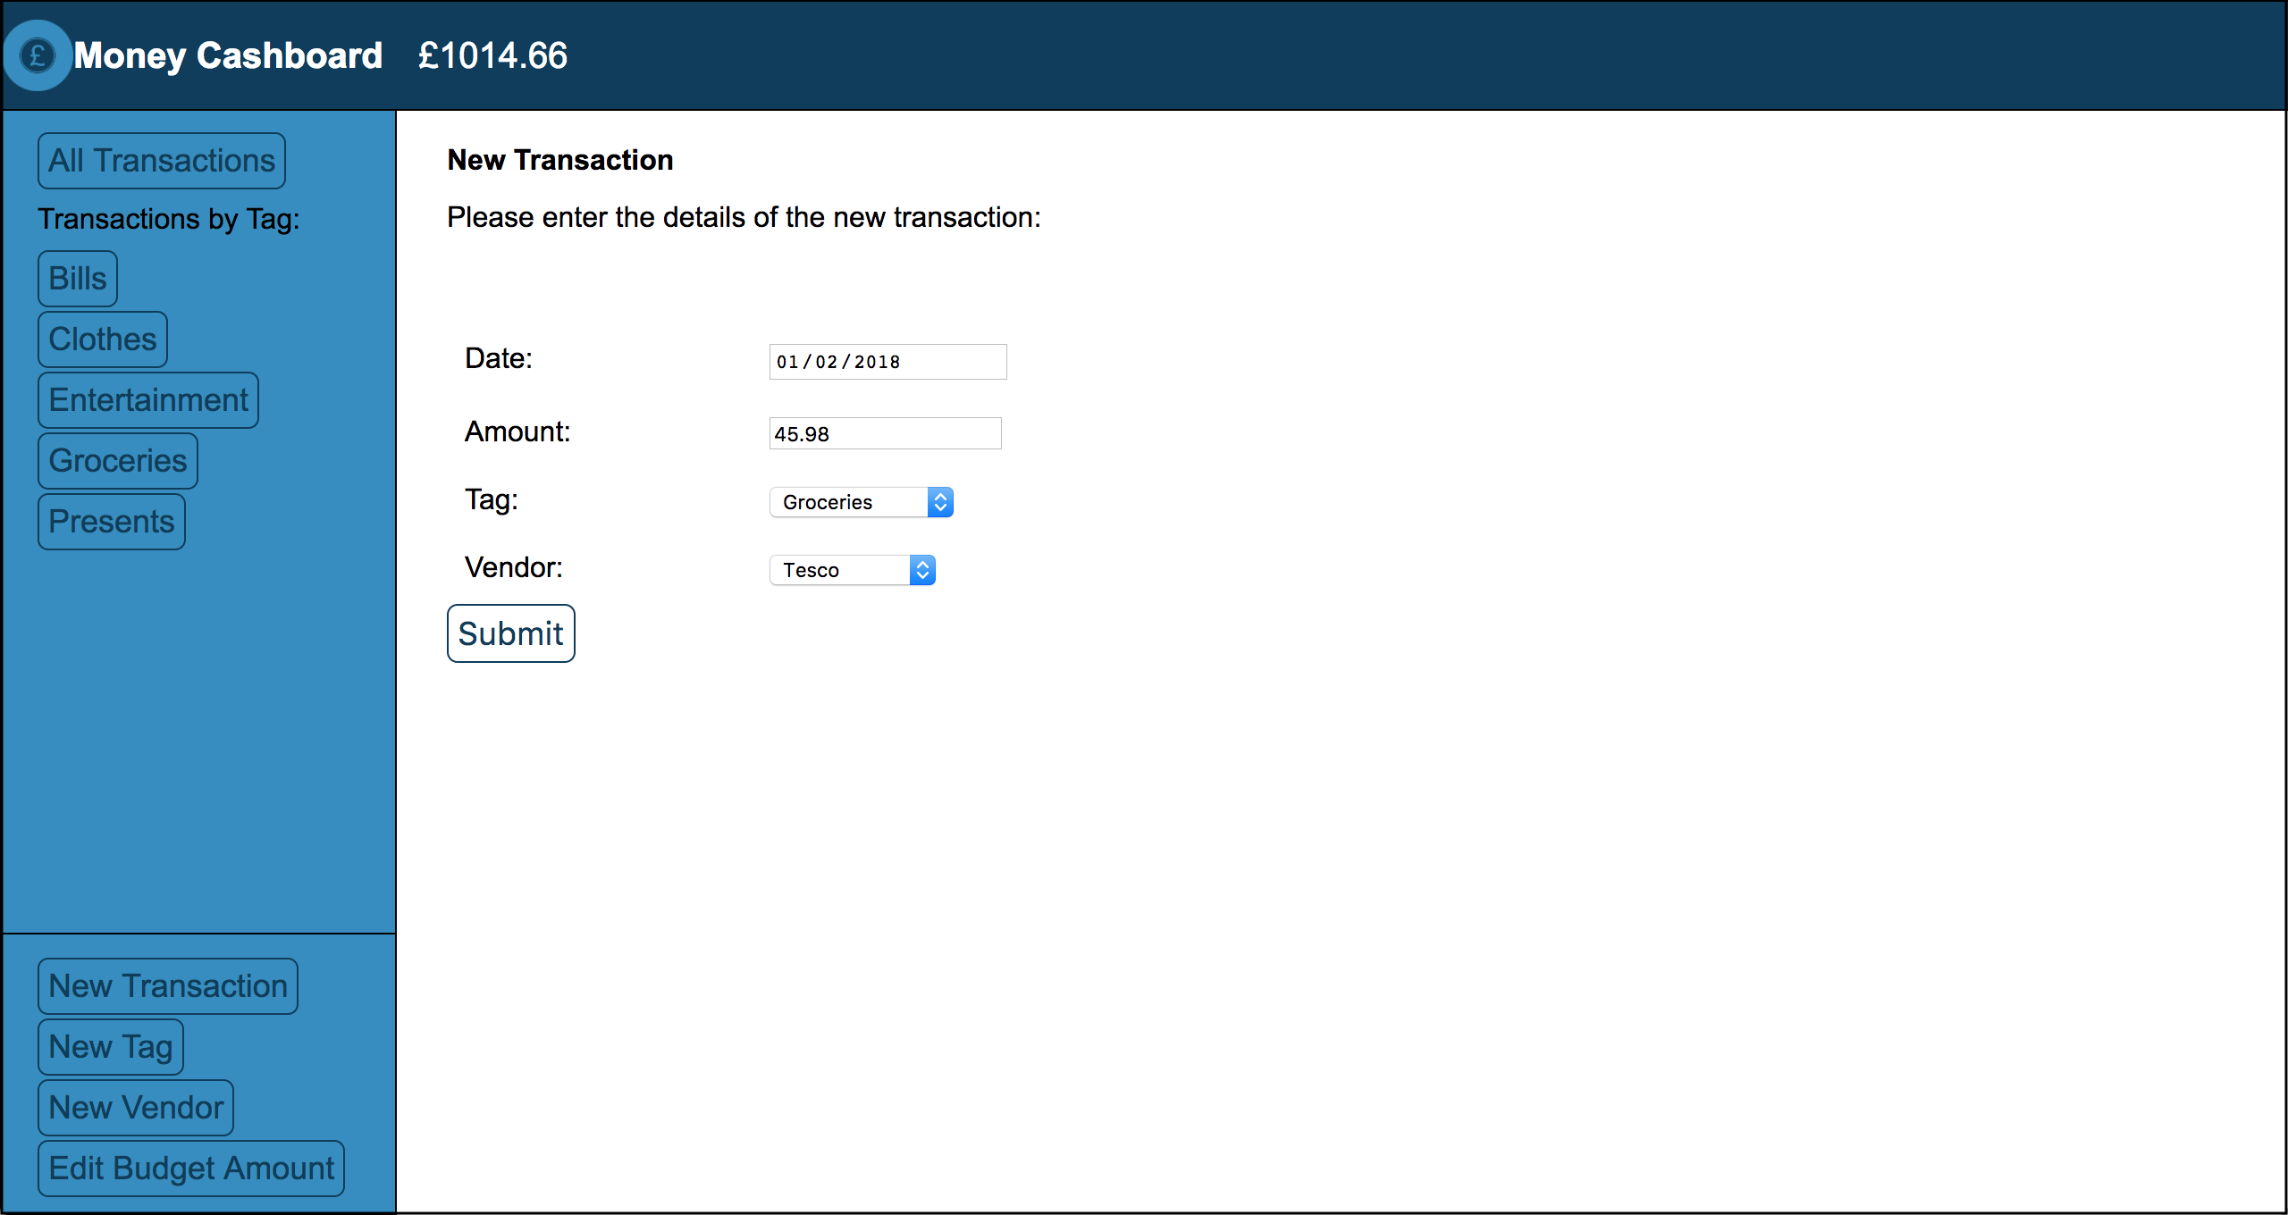

User input saved:

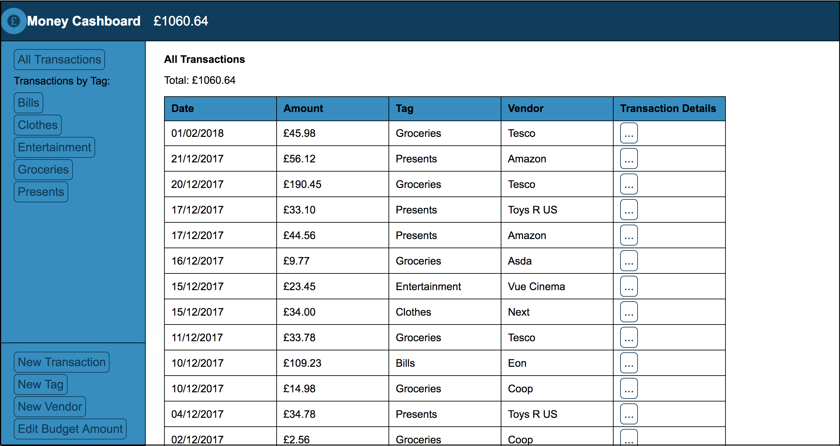

## P14 – Data Interaction and Persistence Screenshots

User Input:

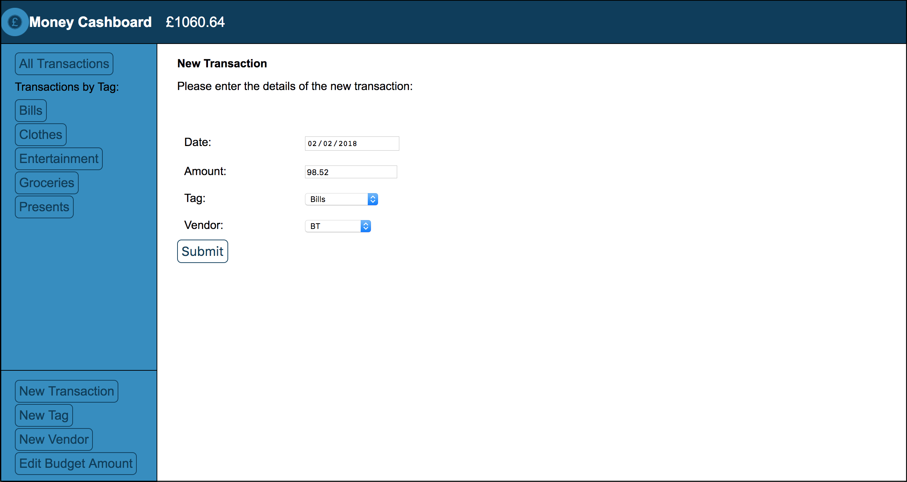

Data saved in database:

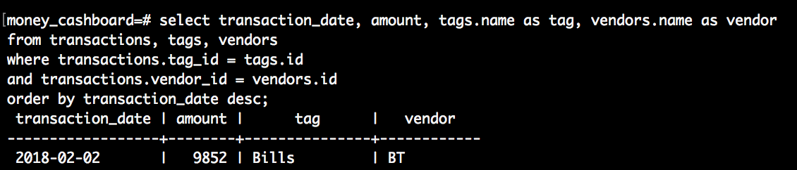

## P15 – User Feedback/Output Screenshots

The user wants to see only the transactions with the “Bills” tag, so they click on the Bills button under Transactions by Tag:

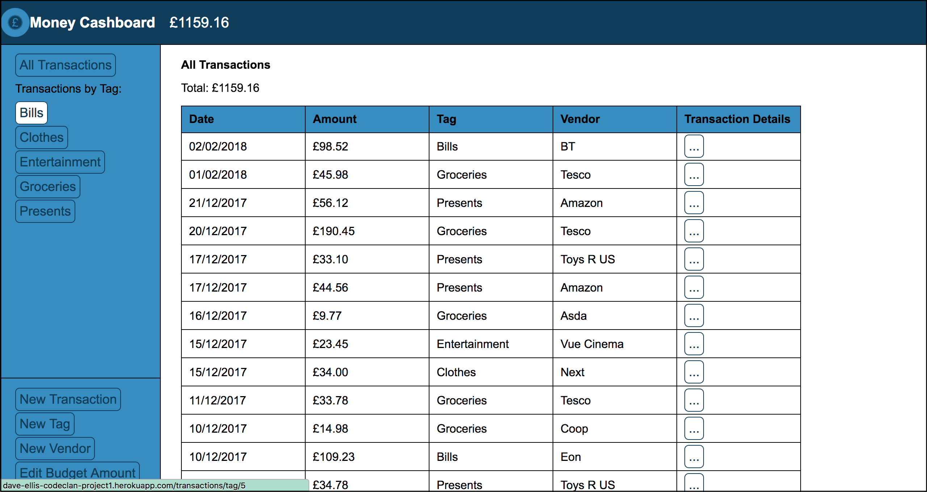

The program responds by showing only the transactions with the Bills tag in the table:

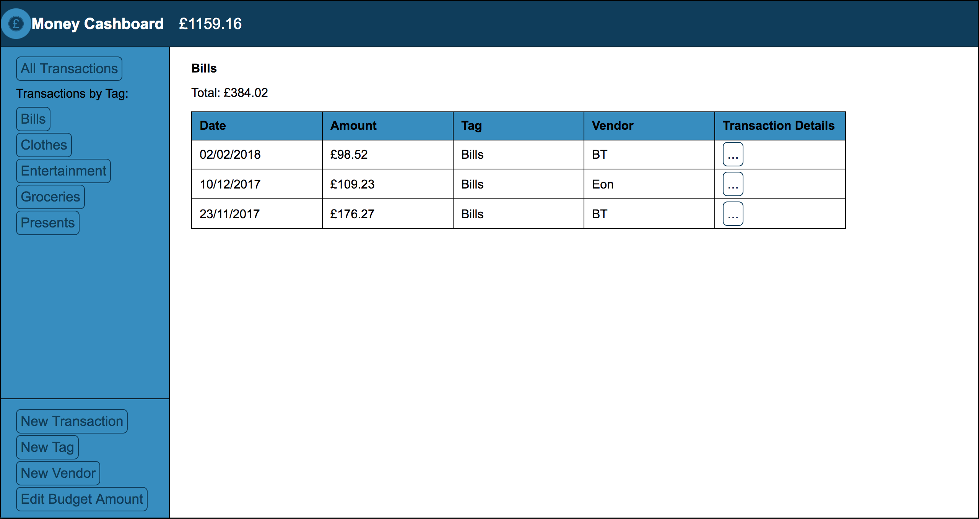

## P16 – API Usage Screenshots

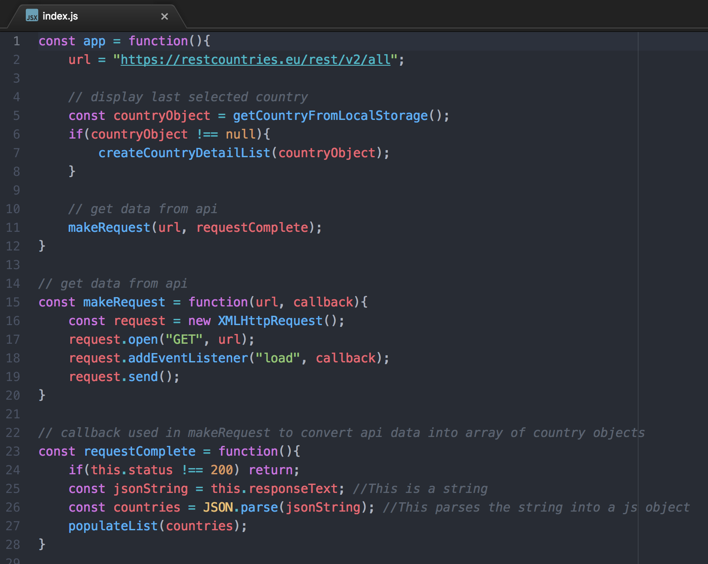

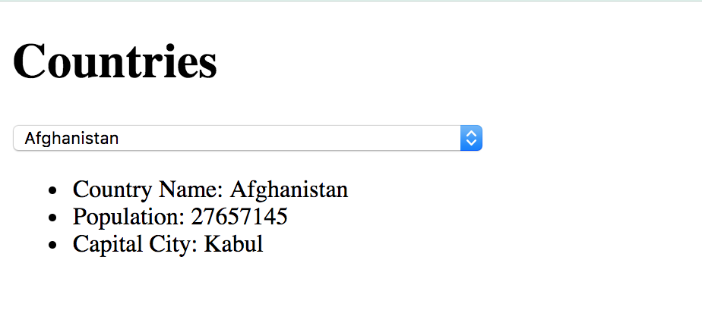

## P17 – Bug Tracking Report *W14

Produce a bug tracking report – include 5 or 6 examples of bugs (all from the same project)

|  |  |  |  |
| --- | --- | --- | --- |
| Issue | Status | Bug Fix | Status After Fix |
|  |  |  |  |
|  |  |  |  |
|  |  |  |  |
|  |  |  |  |
|  |  |  |  |
|  |  |  |  |

## P18 – Testing Example Screenshots

Example of test code:

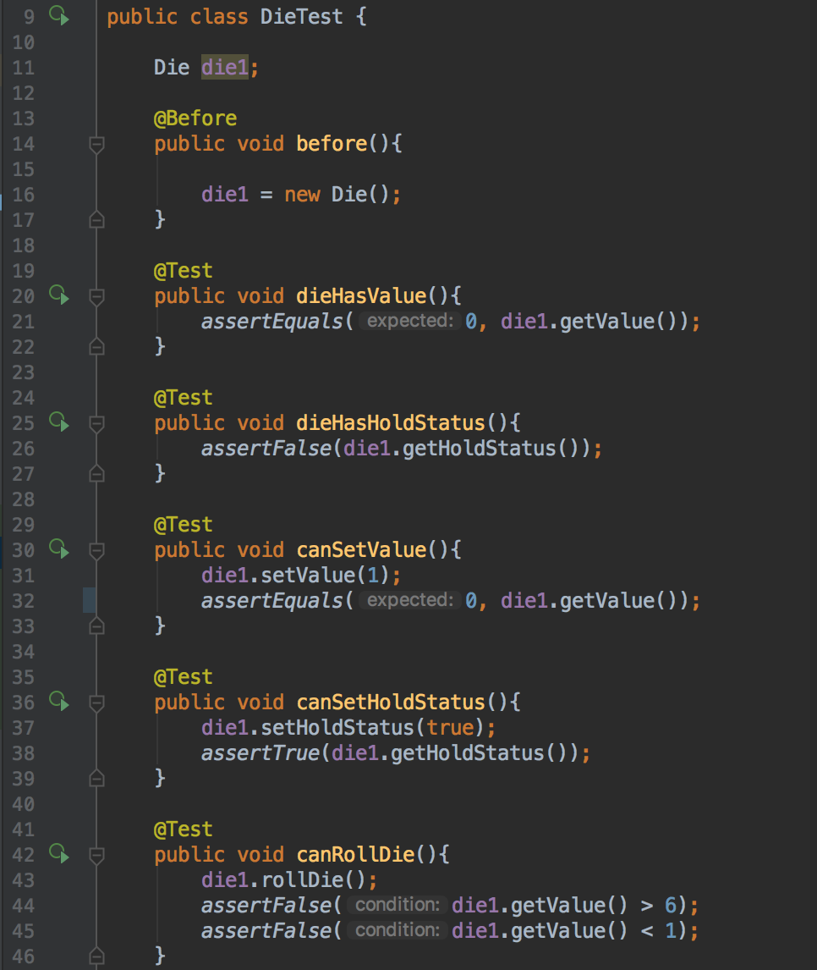

Test failing to pass:

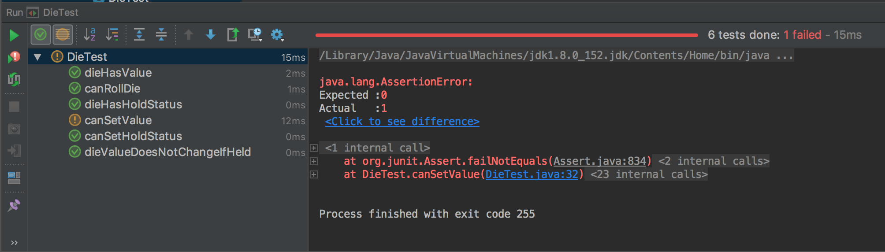

Test code with errors corrected:

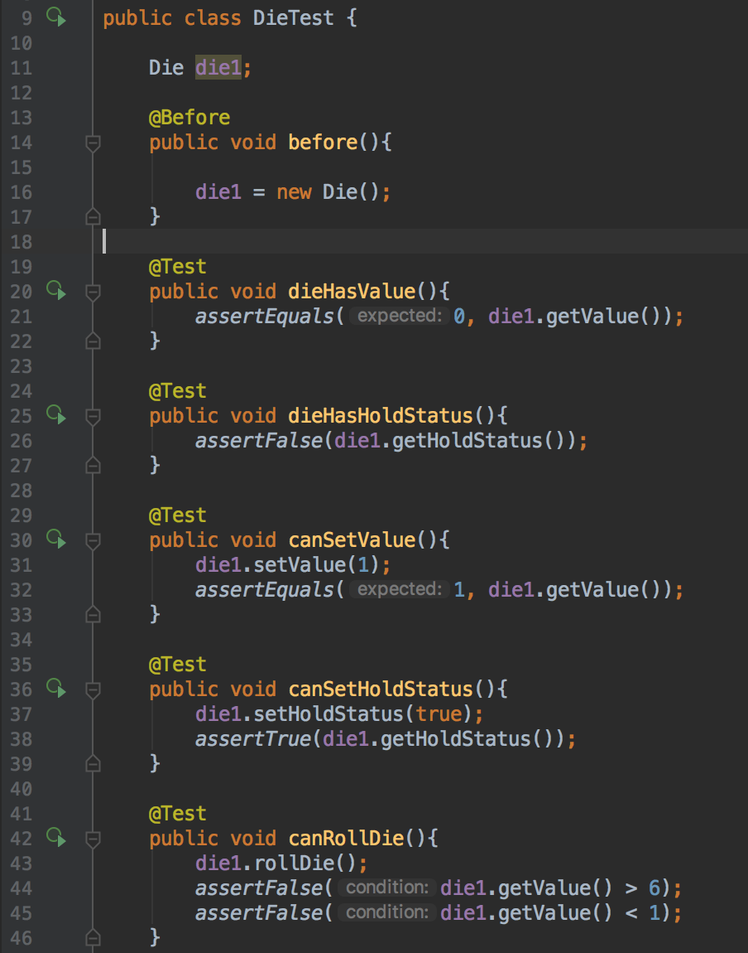

Tests passing:

